1. Trying to keep constant header
2. Fix Payment.html – Increase the sizes
3. 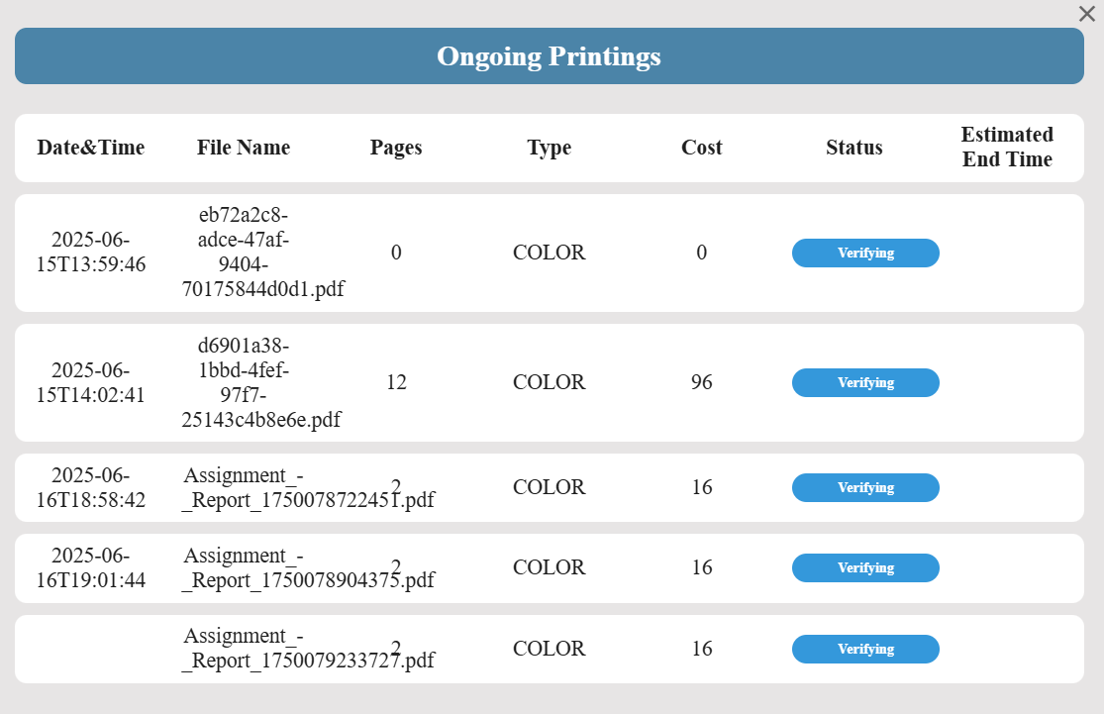Ongoing Printing er size thik kora so that it fits. And Ongoing plus kichu bpr double asche. Oi gula dekha
4. signUpOperator.js has been created. // Done by chumui
5. Signup er por login a data thake na… For operator
6. Homepage a box er sathe image type
7. User: [eid@gmail.com](mailto:eid@gmail.com) Pass: eid
8. Operator: [eva@gmail.com](mailto:eva@gmail.com) Pass: eva123